OntoImport Suite demo files

for PLOS ONE paper

This document first describes how to work with the (already created) ontologies, i.e. how they are supposed to be used with the OntoImport Suite tools. The second part explains the steps that are necessary to create the Soarian Ontology.

# Using the OWL files with OntoImport Suite

To open the demo dataset for the PLOS ONE paper, copy the contents from the folder *"01 Dataset"* into the root directory of the i2b2 OntoImport Suite, version 26 or later (separate download). Replace duplicate files.

**QuickMapp (Mapping Editor)**

Launch QuickMapp.jar. Click on the "Open" button at the top of the window.

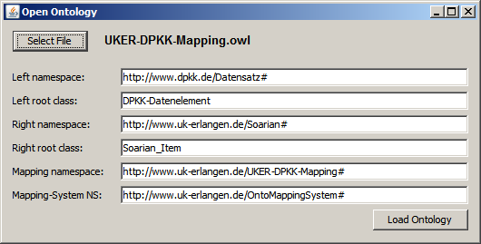

In the "Open Ontology" dialog, click on "Load Ontology". The tool loads the ontologies and displays some statistics:

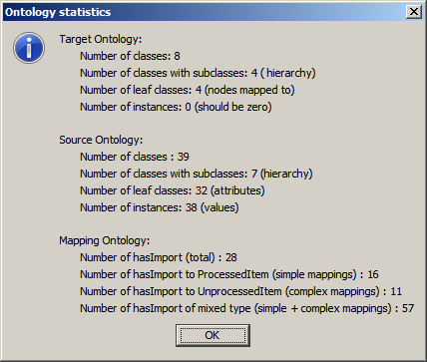

You can now use QuickMapp and view/edit the demo mappings:

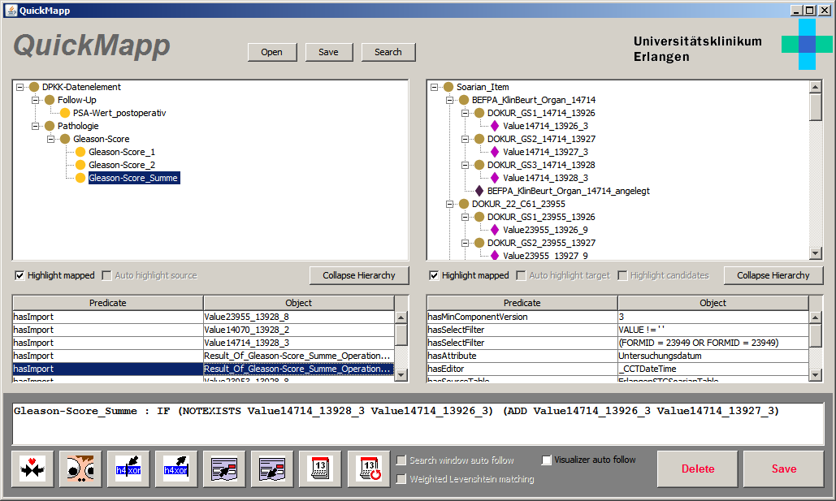

**OntoExport (OWL-2-SQL translator)**

Launch OntoExport.jar. The program should already be configured, so you can directly click on "Start". The tool then generates the SQL code:

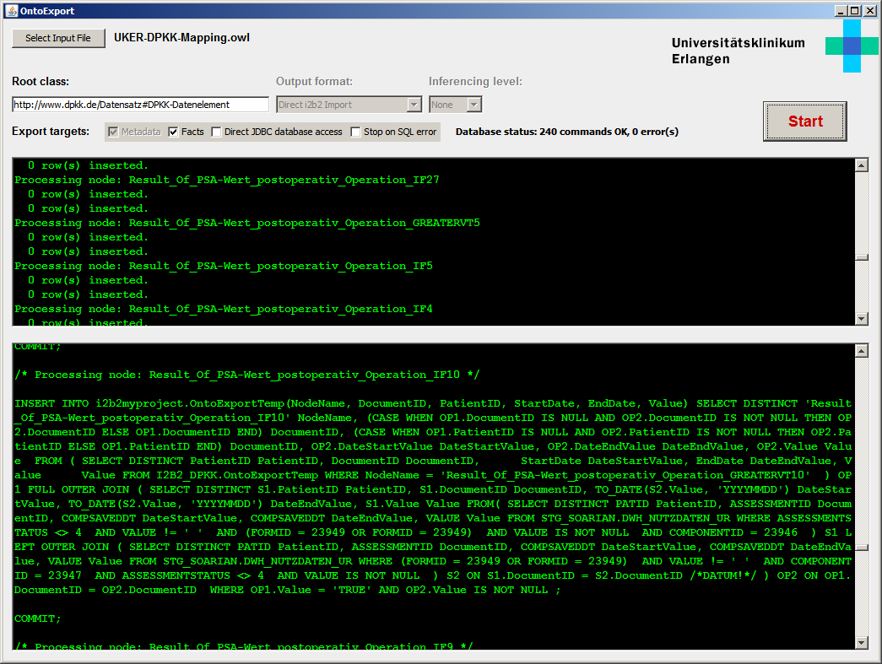

**OntoEdit (editor for target ontologies)**

Launch OntoEdit.jar. The program should already be configured, so you can directly click on "Load". You can use this tool to modify target ontologies.

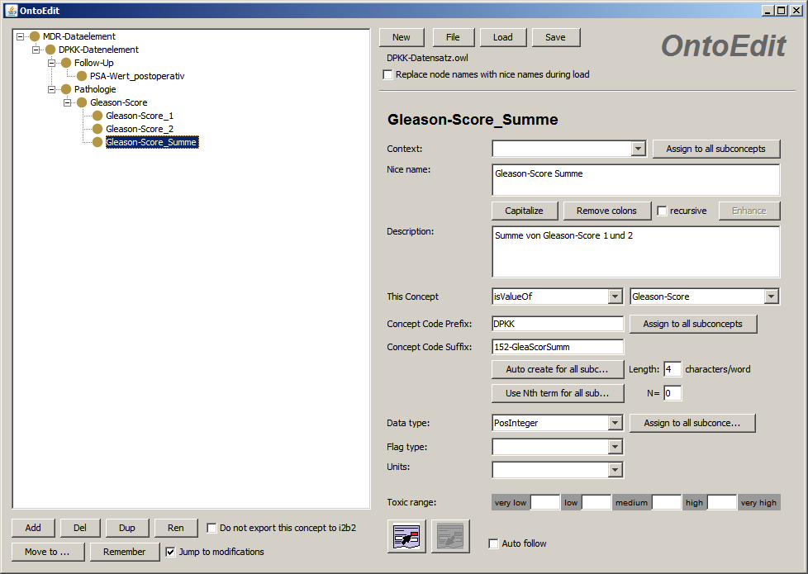

# How to create the Soarian EHR ontology

This part illustrates how the Soarian source ontology has been created.

The relevant metadata for this demo have been made available in the file *"01 Ontologies\02 Load Soarian Metadata.sql".* You can use an Oracle DB to upload this data (the script in *"01 Ontologies\02 Prepare Demo Subset.sql"* was used to create this file by filtering out all metadata that is not necessary for this demo).

After having loaded *"01 Ontologies\02 Load Soarian Metadata.sql"*, run *"03 Metadata-2-OWL\DWH2ONT_PLOSDEMO.sql"* on the same schema. This creates the three tables ONTOLOGY_N3, ONTOLOGY_N3_MAPPING and ONTOLOGY_N3_TARGET. Only the first one is relevant, as this contains the triples for the Soarian source ontology. The others provide the triples for a target and a mapping ontology (self-mapping), which can be used to later transfer the whole Soarian data into i2b2 - but we're not using it here.

Export the table ONTOLOGY_N3 as plain text with Oracale SQLDeveloper and place it in the *"04 Finalizer"* directory.

Next, download the binary distribution of the Jena framework, version 2.6.4 and place it in the *"04 Finalizer"* directory as well. Next, run Finalize.sh on a Linux machine. The script converts the triples from the text file into valid OWL. It creates *Soarian.owl*, the Soarian source ontology.